TRAINING SAMPLE — This document contains intentional accessibility errors for practice.
It is not a real or model document.
2026 Open Enrollment: Your Benefits, Your Choice


It’s time to review your benefits for the coming year. During open enrollment, you can make changes to your health, dental, vision, and life insurance coverage. If you’re satisfied with your current plan, no action is needed—your existing elections will roll over automatically.
All eligible state employees, including full-time and part-time employees working 20 or more hours per week, may participate. Retirees should contact the Retiree Benefits Office for separate enrollment instructions.
What’s New for 2026

Several changes are taking effect this year that may impact your coverage decisions. Review these updates carefully before making your elections.
– Standard PPO premiums increase by 3.2% to reflect rising healthcare costs
– New telehealth benefit: $0 copay for virtual visits on all plans
– High-Deductible plan now includes a $500 employer HSA contribution
– Dependent coverage extended to age 26 for all plan types

Plan Comparison
The chart below compares monthly premiums, deductibles, and key features across all three plan options. Use this to help decide which plan is right for you and your family.
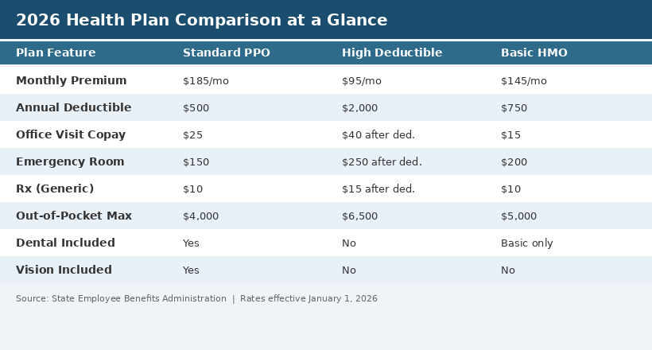
Figure 1: 2026 Health Plan Comparison

How to Enroll
Log in to the Employee Benefits Portal at benefits.state.gov using your state employee credentials. From the dashboard, select “Open Enrollment” and follow the prompts to review and update your elections. You will receive a confirmation email within 24 hours of submitting your changes.
If you need assistance, contact the Benefits Help Desk at 1-800-555-BENEFITS (1-800-555-2363), Monday through Friday, 8:00 AM to 5:00 PM. In-person enrollment sessions are also available at your agency’s HR office.

Key Dates
Date | Event
October 15, 2026 | Open enrollment begins
October 22, 2026 | Benefits fair (all locations)
November 1, 2026 | Last day to schedule 1-on-1 benefits counseling
November 15, 2026 | Open enrollment closes at 11:59 PM
January 1, 2027 | New coverage takes effect
Important: This notice is provided as a summary of available benefits. It does not constitute a contract or guarantee of coverage. In the event of a conflict between this notice and the official plan documents, the plan documents will govern. Employees should review the full Summary Plan Description (SPD) available on the Benefits Portal before making enrollment decisions. Pre-existing condition limitations may apply to certain plan changes.

Questions?
The Benefits Help Desk is available to answer your questions and guide you through the enrollment process. You can also attend a virtual Q&A session every Wednesday at noon during the enrollment period.
Contact
State Employee Benefits Administration
benefits@state.gov | 1-800-555-2363

